 

SUB-CON INFORMATION SHEET

Sub-con EID Number (to be filled by office staff): Sub-con Name: Jayashree Ragavan

Date of Joining: 11th May 2022 Vendor Name: Ibridge Techsoft Designation/Level: Sr.Software Test Engineer

Date of Birth: 05-08-1990 Marital Status: Unmarried

Gender: Female Blood group: O+ve

Personal Identification Mark: Mole on left hand

Academic Qualification(s) & Year: BE - 2012

Degree Certificate available: Yes

Total Experience (In Months): 37

Previous Employer’s Experience Certificate Available: Yes / ~~No~~

Personal Email ID: rjayashree632@gmail.com Passport No: U2096646 Date of issue: _ 26/12/2019

Place of Issue: Chennai Expiry Date: 25/12/2029 Visa Rejected any time: ~~Yes~~ / No

Availability of Overseas: ~~Yes~~ / No

Present Address/: No 10 Bharathidasan Street, Ma.po.si Salai Behind SBI Tiruvallur- 602001 Telephone No : +91 8925277632

Permanent Address/: No 10 Bharathidasan Street, Ma.po.si Salai Behind SBI ,

Tiruvallur- 602001

Telephone No : +91 8925277632

Signature of the Resources (New Joinee): 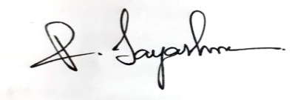

Date: 09/05/2022 Place: Tiruvallur _